Workflow required for Projects:
GTAS Asia EMEA Product
GTAS Asia EMEA Projects

This is the workflow we require, but please note the circled status should be IN REVIEW, not IN UAT
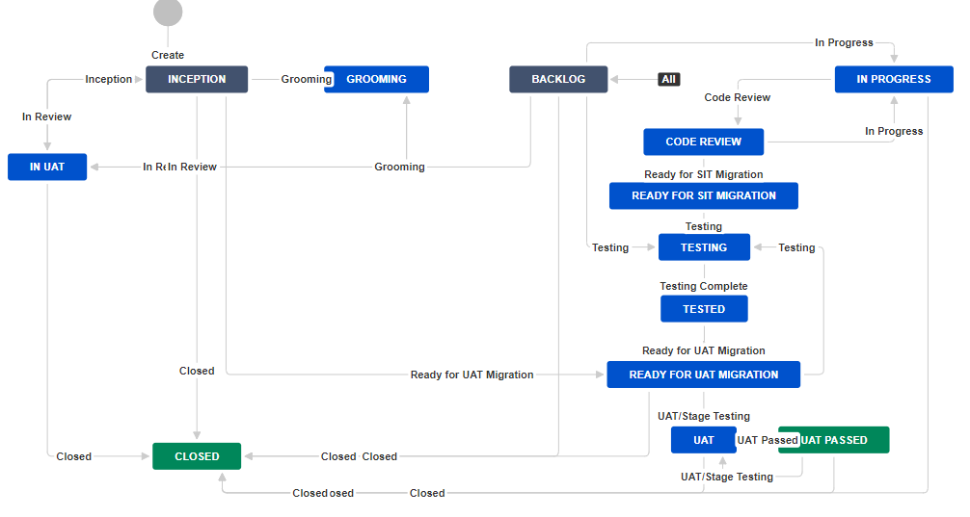
(sorry about the transition labels overwriting, I could not obtain a better snapshot)

